## Activity Dependency Table:

|  |  |  |  |
| --- | --- | --- | --- |
| Activity Code | Activity | Predecessor(s) | Time Duration (Days) |
| A | Identify Key Stakeholders | - | 5 |
| B | Organize Initial Meeting | A | 4 |
| C | Gather Feedback | B | 4 |
| D | Define Objectives | B | 3 |
| E | Draft Scope Statement | C, D | 5 |
| F | Elicit Requirements | E | 7 |
| G | Specify FRs and NFRs | F | 6 |
| H | Define Milestones | F | 4 |
| I | Establish Timeline | H | 3 |
| J | Establish Components (Architecture) | G | 7 |
| K | Define DFDs | J | 5 |
| L | Create ERD | J | 5 |
| M | Develop DB Schema | L | 6 |
| N | Design UIs | F | 7 |
| O | Create Mockups | N | 6 |
| P | Implement User Dashboards | O | 10 |
| Q | Develop Forms | O | 7 |
| R | Ensure Responsiveness | P, Q | 6 |
| S | Database and API Integration | M | 12 |
| T | Implement Business Logic | K | 10 |
| U | Implement Role-Based Access Control | S | 8 |
| V | Connect Frontend & Backend | R, T, U | 10 |
| W | Test Individual Modules | V | 7 |
| X | Conduct Integration Testing | W | 6 |
| Y | Validate End-to-End Processes | X | 6 |
| Z | Prepare Test Cases | Y | 4 |
| AA | Conduct UAT Sessions | Z | 6 |
| AB | Handover the Project | AA | 7 |

## Network Diagram:

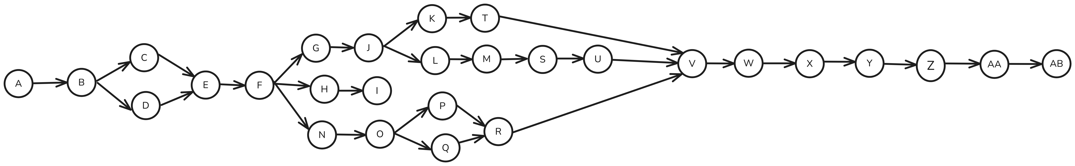

## Critical Path:



**Duration:**

5 + 4 + 4 + 5 + 7 + 6 + 7 + 5 + 6 + 12 + 8 + 10 + 7 + 6 + 6 + 4 + 6 + 7 **= 115 Days**

## Dependent and Independent Activities:

Independent activities are those that can be executed independently without dependence on others. In this Project, only **activity A** is independent.

Dependent activities cannot be executed independently. They cannot be executed until the predecessor activity is finished. In this Project, all activities except activity A are independent.